
Capstone Project Phase A

Ultra Sound Data Transfer Many To Many
An Android Based Application for Data Transfer, using Ultrasound Waves.

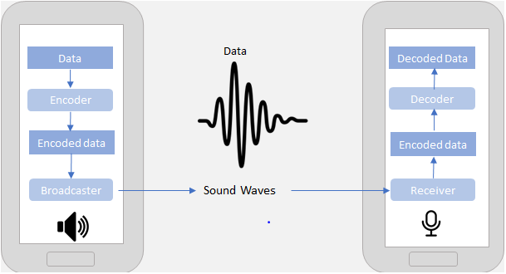

Authors:
Tal Zilberman, email- Tal.Zilberman@e.braude.ac.il
Ariela Havkin, email- Ariela.Havkin@e.braude.ac.il

Supervisor:
Dr. Elena Ravve

Group number:
21-2-D-16
Table of Contents:

- Intreduction 3
- Backround and related work 6
- Expected Achievements: Our Approach- Ultrasonic sound based data transfer. 26
- Research / Engineering Process 31
- Preliminary Software Engineering – Product 38
- Evaluation/Verification Plan-Testing plan 40
- References 41

Abstract. Mobile devices can use a variety of transferring data methods mostly based on cellular communication that requires at least existence of a subscriber identification module (SIM) in the device. In this project we address a challenge of data transferring between the devices, when the cellular communication is un-available (in particular, even when there is no SIM's in the devices at all.) To do so, we propose ultrasonic sound-based communication method and its implementation, which do not need an additional hardware or any other type of connectivity. In order to illustrate the method and its application, we implement an application, called "A Big Brother", which is a server-client application that is aimed to help the health department detect long encounters between people in light of the corona-virus pandemic reality. Our application is Android based and will work 24/7 in background of each device that loaded it. To achive non-wired ultrasonic communication network, we implement communication protocol based on collision avoidance and the use of prime numbers and waiting periods. All the information is stored in the mobile device. Encounters longer then 15 minutes in certain distance will be uploaded to the cloud and sent to the health department when needed and cellular communication is available.
Keywords: ultrasonic, Android, wave frequencies, information transfer, collision avoidance, waiting periods.

Introduction
One of the possible problems that one faces when her/his lifestyle imposes on her/his the burden of being in touch with many people of many professions is transferring information between mobile devices.
Ever since smartphones became mainstream, we have seen many new technologies emerging that make data exchange possible between mobile devices.
The aim of this project is to implement a new method for transmitting information (in our particular case: an id number) from one Android based mobile device to another. We referenced the security mechanisms of Android because of its open source nature and the tools available to extend Android security. We are not interested in any data-based channel like Internet, Wi-Fi or Bluetooth but rather want to use voice-based communication only. We used an ultrasonic sound that phone speakers can produce, phone microphones can hear but humans cannot.
Normally, humans can only hear sound frequencies ranging from 20Hz to 20 KHz. But due to age taking its’ toll this range can get smaller by time (as depicted in Fig. 1).
As it can be seen on Fig. 1, most humans over the age of 18 cannot hear frequencies above 17 KHz ‎[1]. These high frequency sounds are what is known as ultrasonic sounds that are too high for humans to hear, but phone microphones can easily detect. Android applications are regulated by a permission system that enforces the principle of least privilege; we referenced the security mechanisms of Android because of its open source nature and the tools available to extend Android security. At install time, users are presented with a list of dangerous permissions the application requires to function correctly.
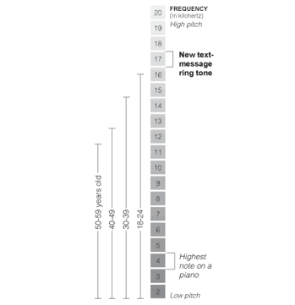
Last year, two groups of students worked together and successfully accomplished to create a communication channel between two Android based devices, using ultrasonic waves. In their projects, they successfully transmitted data (in the form of visit cards) between devices, using an Android application they created – SVC.
Figure 1: Hearing ranges by age group‎[1]

This year, we strive the expand this communication channel to a network. We intend to create a communication channel in the form of a Corona tracking app (similar to the Ministry of Healths' app, the Magen).

The Reason To Transfer Over Sound:
There are very clear and practical affordances of data over sound ‎[29]. From its seamless integration into existing hardware and frictionless connections, to its ability to work offline in even the most extreme environments, there are myriad potential use cases for data-over-sound.
Data-over-sound has a multitude of complementary capabilities when compared to other connectivity technologies. The technology’s position as a pairing-free, one-to-many medium means it mitigates some of the setup and provisioning pain points often associated with traditional alternatives such as Bluetooth and Wi-Fi, presenting an appealing and versatile solution for frictionless data transmission. In general, compared to other technologies, data-over-sound is also able to be used in very wide application areas, taking advantage of existing hardware and without prior setup or configuration.
Doing so, it enables the interconnection of millions of devices in a seamless, scalable, and cost-effective way to enhance end-user experience and drive value without increasing hardware costs. This ability to enhance existing infrastructure has inevitably captured the interest of companies interested in adding wireless connectivity functionality without adding to their bill of materials.
The future for seamlessly connected devices lies in utilizing a broad range of connectivity solutions, including data-over-sound, where each technology complements the others in the suite. Working in conjunction with other solutions, data-over-sound exists as an essential component of fulfilling the promise of ubiquitous, frictionless connectivity.

The Benefits of Sending Data over Sound
Embedding and extracting meaning from sound provides a quick, secure, and cost-effective solution that works completely offline. Inevitably, there’s no “one-size-fits-all” data-transfer solution that will be optimal in all environments and purposes. Yet, in many situations, data-over-sound is now emerging as an ideal medium for simple implementation and reliable connectivity ‎[29]. Some of the clearest affordances of sound include:
- Works offline
Sound works peer-to-peer, or one-to-many, meaning no additional connections are needed to “the cloud” or other network services. Thus, data-over-sound software works well in a situation where there’s no network access, like rural or RF-restricted areas.
- Utilize existing hardware
The rise of microphones in IoT devices means that the hardware requirements are already met for billions of existing devices of all form factors. Combined with the arrival of zero-power microphones, data-over-sound provides an extremely low power, “always connected,” device-to-device data-transfer solution. Eliminating the need for additional hardware saves users both money and resources that can be invested back into the business.
- Secure, private data transfer
Because acoustic connection doesn’t require an internet connection and supports industry-standard cryptography, you’ll have peace of mind that any data transferred will not be compromised. No audio, not even audio metadata is ever stored or sent from a receiving device for processing.
- Supports range of platforms
Data-over-sound is compatible with machines and devices of different platforms, form factors, and architectures that can process audio. From smartphones and tablets to toys and games, and even legacy and analog equipment, any device with a microphone and speaker can receive and decode data with the technology.
- Seamless integration
Often implementing new software can be resource- and time-intensive. However, data-over-sound can be delivered through software-development kits (SDKs), which provide a fast and easy integration to a host of platform types, making the solution ideal for hobbyist developers and IoT projects.
- Scalable
With data-over-sound, there’s no need to reengineer as your application grows. Whether the aim is to enable seamless P2P exchanges or send data from one-to-many, this method of data transfer is completely scalable. Use cases for data-over-sound are therefore wide ranging. They can include IoT devices sending and receiving commands, secure transactions, and un-spoofable receipts to merchants or buyers, as well as sending/receiving credentials (to provision Wi-Fi, for example).
- Works in extreme environments
Through a range of frequencies, data-over-sound software is robust to background noise and has been proven to work seamlessly in the most extreme environments. From the streets of Delhi to nuclear power stations, acoustic network connectivity remains universally strong in the toughest environments.

Our Plan
The previous groups that worked on this project, successfully implemented a new method that allows exchanging of information between Android-based devices via inaudible sound waves (i.e. ultrasonic data transfer). To do so, they searched for different coding methods and choose frequency-shift keying. Moreover, they researched the dependency of the quality of the transferred data upon different factors such that: characteristics of the devices, the distance between them, and so on.
In addition, they considered the side effects like sound noise. Also, they found that high frequencies can be heard by animals like dogs because some animals can hear higher frequencies than humans.
Last year, the groups managed to create a one- to- one communication channel based on the ultrasonic waves.
Our goal this year, is to expand the communication channel from one- to -one, to many- to- many.
To do so, we will use a collision avoidance protocol, that will allow us to create a network of a finite number of devices. Moreover, we will use cryptographic methods to secure the communication within the network.

The Reason It Is Not Trivial
The described above challenges of our project are not trivial because we will need to deal with absolutely new technology: voice-based information transfer in ultrasonic mode on Android devices. It is a new development area for us. We will learn Android development, in addition to learning how to create a network, and implementing the cryptographic theories we researched.
Moreover, we will go deeper into understanding how speakers and microphones work on different phones, as some phones in the market filter frequencies, or can’t identify them good enough, while others don’t accurately generate high frequency. Thus, they are not supporting the data transfer method we are working on.

Backround and related work

Sound
Sound ‎[6] is produced when an object vibrates the air around it, and this vibration can be represented as a wave that travels through space. For example, if a branch falls off a tree and hits the ground, the air pressure around the branch changes when it hits the earth and, as a result, the vibration of the air produces a sound originating from the collision.
One thing that many people do not realize is that sound waves have physical properties and are therefore influenced by the environment in which they occur. In the vacuum of space, for instance, sounds cannot occur because, in a true vacuum, there is nothing to vibrate and cause a sound wave. The two most important physical qualities of sound are frequency and amplitude.
Frequency is the speed at which a sound wave vibrates, and it determines the pitch of a noise. Higher frequency sounds have a higher pitch, like a flute or a bird chirping, while lower frequency sounds have a lower pitch, like a tuba or a large dog barking. The amplitude of a sound wave can be thought of as the strength of the vibrations as they travel through the air, and it determines the perceived loudness of the sound.
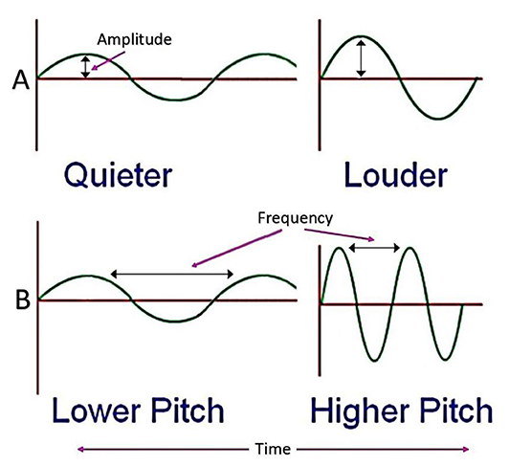
As you can see on Fig. 2, when the peak of the sound wave is smaller, the sound will be perceived as quieter. If the peak is larger, then the sound will seem louder. It might even help to think of sound waves like waves in an ocean. If you stand in still water and drop a pebble near your legs, it will cause a small ripple (a tiny wave) that does not affect you much. But if you stand in the ocean during stormy weather, the large incoming waves may be strong enough to knock you down! Just like the size and strength of water waves, the size, and strength of sound waves can have a big effect on what you hear.
Figure 2: Amplitude and frequency represented as waves ‎[6]

Amplitude
It is the strength of the vibrations as they travel through the air, the greater the amplitude, the louder the sound is perceived by the observer.

Frequency
It is the speed at which a sound wave vibrates, which determines the perceived pitch of the noise, the greater the frequency, the higher the pitch of the sound.

Pitch
It is the quality of sound that is experienced as a function of the frequency or speed of the vibrations, the perceived degree of highness or lowness of a tone or sound.

Ultrasonic
Ultrasonic ‎[7] is sound waves with frequencies higher than the upper audible limit of human hearing. This limit varies from person to person; humans with ideal hearing can perceive sound frequencies within the range of 20 Hz to 20 kHz. However, sensitivity to high frequencies declines rapidly with age; most humans over 18 years of age cannot hear frequencies above 17 kHz as shown in Fig. 1.
Ultrasonic is not different from “normal” sound (audible sound) in its physical properties, expect that humans cannot hear it.
A significant amount of inaudible frequencies can be produced by mobile device speakers. The small speakers on such devices are better at creating high frequencies. These inaudible frequencies can also be detected by microphones. Therefore, machines can communicate with sound frequencies that most humans cannot hear.
Ultrasonic is used in many different fields, such as to measure distances, imaging, or sonography used in medicine. In our project, we used it as a transferring data method between Android devices.

Different Methods of Voice-based Data Transfer
There are different methods for voice-based data transfer; all these methods are under passband modulation, where a passband is the range of frequencies or wavelengths that can pass through a filter. For example, a radio receiver contains a bandpass filter to select the frequency of the desired radio signal out of all the radio waves picked up by its antenna. The passband of a receiver is the range of frequencies it can receive.
A modulation in electronics and telecommunications is the process of varying one or more properties of a periodic waveform, called the carrier signal, with a modulating signal that typically contains information to be transmitted. Most radio systems in the 20th century used frequency modulation (FM) or amplitude modulation (AM) for radio broadcast.
Passband modulation includes different types of modulations:

Analog Modulation
In analog modulation, cf. ‎[20], the modulation is applied continuously in response to the analog information signal. Common analog modulation techniques include:
  - Amplitude Modulation
Amplitude modulation (AM), cf. ‎[10], is a modulation technique used in electronic communication, most commonly for transmitting information via a radio carrier wave. In amplitude modulation, the amplitude (signal strength) of the carrier wave is varied in proportion to that of the message signal being transmitted. The message signal is, for example, a function of the sound to be reproduced by a loudspeaker, or the light intensity of pixels of a television screen. This technique contrasts with frequency modulation, in which the frequency of the carrier signal is varied, and phase modulation, in which its phase is varied.
AM was the earliest modulation method used for transmitting audio in radio broadcasting. It was developed during the first quarter of the 20th century beginning with Roberto Landell de Moura and Reginald Fessenden's radiotelephone experiments in 1900, cf. ‎[11]. It remains in use today in many forms of communication. For example, it is used in portable two-way radios, very high frequency ‎[27] aircraft radio, citizens band radio, and in computer modems in the form of quadrature amplitude modulation ‎[28]. AM is often used to refer to mediumwave AM radio broadcasting.
  - Frequency Modulation
Frequency Modulation (FM), cf. ‎[12], is the encoding of information in a carrier wave by varying the instantaneous frequency of the wave.
In analog frequency modulation, such as FM radio broadcasting of an audio signal representing voice or music, the instantaneous frequency deviation, the difference between the frequency of the carrier and its center frequency, is proportional to the modulating signal.
Digital data can be encoded and transmitted via FM by shifting the carrier's frequency among a predefined set of frequencies representing digits – for example one frequency can represent a binary 1 and a second can represent binary 0. This modulation technique is known as Frequency-Shift Keying (FSK). FSK is widely used in modems such as fax modems and can also be used to send Morse code, cf. ‎[13]. Radioteletype also uses FSK, cf. ‎[14]
Frequency modulation is widely used for FM radio broadcasting. It is also used in telemetry, radar, seismic prospecting, and monitoring newborns for seizures via ElectroEncephaloGraphy - EEG, cf. ‎[15] two-way radio systems, sound synthesis, magnetic tape-recording systems and some video-transmission systems. In radio transmission, an advantage of frequency modulation is that it has a larger signal-to-noise ratio and therefore rejects radio frequency interference better than an equal power amplitude modulation (AM) signal. For this reason, most music is broadcast over FM radio.
Frequency modulation and phase modulation are the two complementary principal methods of angle modulation; phase modulation is often used as an intermediate step to achieve frequency modulation. These methods contrast with amplitude modulation, in which the amplitude of the carrier wave varies, while the frequency and phase remain constant.
  - Phase Modulation
Phase modulation, cf. (PM) ‎[16], is a modulation pattern for conditioning communication signals for transmission. It encodes a message signal as variations in the instantaneous phase of a carrier wave. Phase modulation is one of the two principal forms of angle modulation, together with frequency modulation.
The phase of a carrier signal is modulated to follow the changing signal level (amplitude) of the message signal. The peak amplitude and the frequency of the carrier signal are maintained constant, but as the amplitude of the message signal changes, the phase of the carrier changes correspondingly.
Phase modulation is widely used for transmitting radio waves and is an integral part of many digital transmission coding schemes that underlie a wide range of technologies like Wi-Fi, global system for mobile communication and satellite television.
PM is used for signal and waveform generation in digital synthesizers, such as the Yamaha DX7, to implement FM synthesis. A related type of sound synthesis called phase distortion is used in the Casio CZ synthesizers.
Out of all these three, cf. ‎[17], amplitude modulation seems more feasible as it can be sent over low frequencies that are inaudible to human ears and thus, won’t create any humming sound or other distractions. Amplitude modulation also means sending data over longer areas as the sound waves with longer wavelength can easily bypass physical obstructions.
Since the digital data is binary, data can be easily mounted to sound waves by creating a short sound to indicate a 0 and a long sound to indicate the 1. At the receiving end, a demodulation (a modem) can be used to decode the message.
The best method to send data over sound would be to use inaudible frequencies and low amplitudes that can span buildings and other obstructions so that they can reach far off places.

Digital Modulation
In digital modulation ‎[21], an analog carrier signal is modulated by a discrete signal. Digital modulation methods can be considered as digital-to-analog conversion and the corresponding demodulation or detection as analog-to-digital conversion. The changes in the carrier signal are chosen from a finite number of M alternative symbols. Common digital modulation techniques include:
- Amplitude-shift keying (ASK)
Amplitude-Shift Keying (ASK) ‎[22] is a form of amplitude modulation that represents digital data as variations in the amplitude of a carrier wave. In an ASK system, the binary symbol 1 is represented by transmitting a fixed-amplitude carrier wave and fixed frequency for a bit duration of T seconds. If the signal value is 1 then the carrier signal will be transmitted; otherwise, a signal value of 0 will be transmitted.
Any digital modulation scheme uses a finite number of distinct signals to represent digital data. ASK uses a finite number of amplitudes, each assigned a unique pattern of binary digits. Usually, each amplitude encodes an equal number of bits. Each pattern of bits forms the symbol that is represented by the amplitude. The demodulator, which is designed specifically for the symbol-set used by the modulator, determines the amplitude of the received signal and maps it back to the symbol it represents, thus recovering the original data. Frequency and phase of the carrier are kept constant.
Like AM, an ASK is also linear and sensitive to atmospheric noise, distortions, propagation conditions on different routes in PSTN, etc. Both ASK modulation and demodulation processes are relatively inexpensive. The ASK technique is also commonly used to transmit digital data over optical fiber. For LED transmitters, binary 1 is represented by a short pulse of light and binary 0 by the absence of light. Laser transmitters normally have a fixed "bias" current that causes the device to emit a low light level. This low level represents binary 0, while a higher amplitude light wave represents binary 1.
The simplest and most common form of ASK operates as a switch, using the presence of a carrier wave to indicate a binary one and its absence to indicate a binary zero. This type of modulation is called on-off keying (OOK), and is used at radio frequencies to transmit Morse code (referred to as continuous wave operation),
More sophisticated encoding schemes have been developed which represent data in groups using additional amplitude levels. For instance, a four-level encoding scheme can represent two bits with each shift in amplitude; an eight-level scheme can represent three bits; and so on. These forms of amplitude-shift keying require a high signal-to-noise ratio for their recovery, as by their nature much of the signal is transmitted at reduced power. 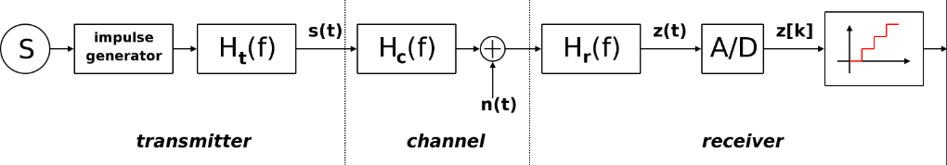
ASK system can be divided into three blocks. The first one represents the transmitter, the second one is a linear model of the effects of the channel, and the third one shows the structure of the receiver. The following notation is used:
Figure 3: ASK diagram ‎[22]
- h_{t}(f) is the carrier signal for the transmission
- h_{c}(f) is the impulse response of the channel
- n(t) is the noise introduced by the channel
- h_{r}(f) is the filter at the receiver
- L is the number of levels that are used for transmission
- T_{s} is the time between the generation of two symbols
- Frequency-shift keying (FSK)
Frequency-Shift Keying (FSK) ‎[8] is a frequency modulation scheme in which digital information is transmitted through discrete frequency changes of a carrier signal ‎[23]. The technology is used for communication systems such as telemetry, weather balloon radiosondes, caller ID, garage door openers, and low frequency radio transmission in the very low frequency and extremely low frequency ‎[8] bands. The simplest FSK is binary FSK (BFSK). BFSK uses a pair of discrete frequencies to transmit binary (0s and 1s) information. With this scheme, the "1" is called the mark frequency and the "0" is called the space frequency.
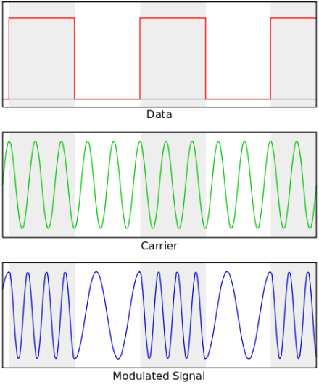
Figure 4: Example of a digital signal represented as analog waves in frequency shift keying ‎[8]
- Phase-Shift Keying (PSK)
Phase-Shift Keying (PSK) ‎[23] is a digital modulation process which conveys data by changing (modulating) the phase of a constant frequency reference signal (the carrier wave). The modulation is accomplished by varying the sine and cosine inputs at a precise time. It is widely used for wireless local area networks, radio-frequency identification and Bluetooth communication.
Any digital modulation scheme uses a finite number of distinct signals to represent digital data. PSK uses a finite number of phases, each assigned a unique pattern of binary digits. Usually, each phase encodes an equal number of bits. Each pattern of bits forms the symbol that is represented by the phase. The demodulator, which is designed specifically for the symbol-set used by the modulator, determines the phase of the received signal and maps it back to the symbol it represents, thus recovering the original data. This requires the receiver to be able to compare the phase of the received signal to a reference signal – such a system is termed coherent.
- An example for representing the data of the three methods of the digital modulation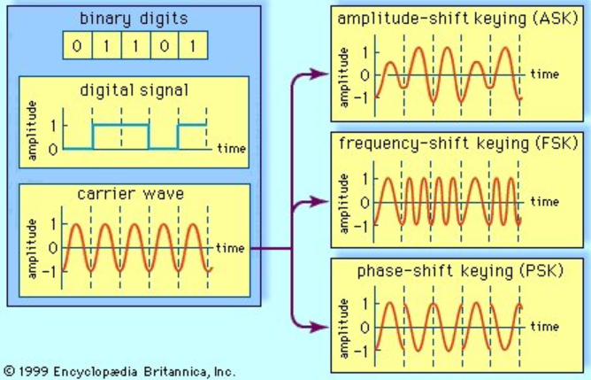
Figure 5: Three methods of digital signal modulation ‎[23]
A digital signal, representing the binary digits 0 and 1 by a series of on and off amplitudes, is impressed onto an analog carrier wave of constant amplitude and frequency. In amplitude-shift keying (ASK), the modulated wave represents the series of bits by shifting abruptly between high and low amplitude. In frequency-shift keying (FSK), the bit stream is represented by shifts between two frequencies. In phase-shift keying (PSK), amplitude and frequency remain constant; the bit stream is represented by shifts in the phase of the modulated signal.

Analog and Digital Signals
Analog and digital signals are used to transmit information, usually through electric signals. In both these technologies, the information, such as any audio or video, is transformed into electric signals. The difference between analog and digital technologies is that in analog technology, information is translated into electric pulses of varying amplitude. In digital technology, translation of information is into binary format (zero or one) where each bit is representative of two distinct amplitudes. Here you are the comparison chart ‎[25]:
Table 1: Analog and Digital Comparison
 | Analog | Digital
Signal | Analog signal is a continuous signal which represents physical measurements. | Digital signals are discrete time signals generated by digital.
Waves | Denoted by sine waves. | Denoted by square waves.
Representation | Uses continuous range of values to represent information. | Uses discrete or discontinuous values to represent information.
Example | Human voice in air, analog electronic devices. | Computers, Compact Discs, Digital Versatile Discs, and other digital electronic devices.
Technology | Analog technology records waveforms as they are. | Samples analog waveforms into a limited set of numbers and records them.
Data transmissions | Subjected to deterioration by noise during transmission and write/read cycle. | Can be noise-immune without deterioration during transmission and write/read cycle.
Response to Noise | More likely to get affected reducing accuracy. | Less affected since noise response are analog in nature.
Flexibility | Analog hardware is not flexible. | Digital hardware is flexible in implementation.
Uses | Can be used in analog devices only. Best suited for audio and video transmission. | Best suited for Computing and digital electronics.
Applications | Thermometer. | Personal Computers, Personal Digital Assistants.
Bandwidth | Analog signal processing can be done in real time and consumes less bandwidth. | There is no guarantee that digital signal processing can be done in real time and consumes more bandwidth to carry out the same information.
Memory | Stored in the form of wave signal. | Stored in the form of binary bit.
Power | Analog instrument draws large power. | Digital instrument draws only negligible power.
Cost | Low cost and portable. | Cost is high and not easily portable.
Impedance | Low. | High order of 100 megaohm.
Errors | Analog instruments usually have a scale which is cramped at lower end and give considerable observational errors. | Digital instruments are free from observational errors like parallax and approximation errors.

Smartphones
Table 1: Analog and Digital Comparison
Smartphones are a class of mobile phones and of multi-purpose mobile computing devices. They are distinguished from feature phones by their stronger hardware capabilities and extensive mobile operating systems, which facilitate wider software, internet (including web browsing over mobile broadband), and multimedia functionality (including music, video, cameras, and gaming), alongside core phone functions such as voice calls and text messaging. Smartphones support wireless communications protocols (such as Bluetooth, Wi-Fi, or satellite navigation).

Android

Android Operating System
Android is software that was founded in Palo Alto of California in 2003. It is a Linux based operating system it is designed primarily for touch screen mobile devices such as smartphones and tablet computers. It is also one of the most widely used mobile operating system these days.
The Android is a powerful operating system, and it supports large number of applications in smartphones. These applications are more comfortable and advanced for the users.
The hardware that supports Android software is based on Advanced RISC Machine (ARM) architecture platform. The Android is an open source operating system means that it’s free and any one can use it.
Android applications are regulated by a permission system that enforces the principle of least privilege. At install time, users are presented with a list of dangerous permissions the application requires to function correctly. These permissions include network access, access to message history, access to contacts, etc. If the user is willing to trust the application with these permissions, they allow the installation to continue. If not, the installation is aborted. In addition, access to the speakers and microphone are not considered dangerous actions and do not require explicit permissions.
Kirin ‎[5] allows users to set custom policies that prevent dangerous combinations of permissions.
TaintDroid ‎[4] tracks sensitive data as it moves within and out of Android devices. TaintDroid can prevent secrets from being exported over network connections, but it does not prevent secrets from being broadcast as sound.
MockDroid ‎[3] provides false data when sensitive data is requested by an application. It can also make an application believe that network access is unavailable. However, an application may be trusted with real data in order to obtain functionality. It can then export the data as sound instead of using the network.

Android Services
A Service is an application component that can perform long-running operations in the background and does not provide a user interface.

Android Application
An Android application is a mobile app. A mobile app is a computer program or software application designed to run on a mobile device such as a phone, tablet, or watch. Apps were originally intended for productivity assistance such as email, calendar, and contact databases, but the public demand for apps caused rapid expansion into other areas such as mobile games, factory automation, GPS and location-based services, order-tracking, and ticket purchases, so that there are now millions of apps available.

Android permissions
The purpose of the permissions is to protect the privacy of an Android user. Android apps must request permission to access sensitive user data (such as contacts and SMS), as well as certain system features (such as camera and internet). Depending on the feature, the system might grant the permission automatically or might prompt the user to approve the request.

Android Software Development Kit – SDK
A software development toolkit (SDK) ‎[36] is a set of software tools and programs provided by hardware and software vendors that developers can use to build applications for specific platforms. These providers make their SDKs available to help developers easily integrate their apps with their services.
In order to use an SDK, a developer needs an iOS SDK to build iOS apps, an Android toolkit for building Android apps, Nordic SDK to build Bluetooth or wireless apps and a VMware SDK to enable integration with the VMware platform.
Although SDKs are largely associated with native mobile apps, developers can use them in connection with websites, set-top boxes and other digital platforms.
SDKs include documentation, application programming interfaces (APIs), code samples, libraries and processes, as well as guides that developers can use and integrate into their apps. Developers can use SDKs to build and maintain applications without having to write everything from scratch.
More specifically, SDKs include:
- Libraries or APIs - pre-defined pieces of code that let developers perform common programming tasks on the platform.
- Integrated development environment (IDE) – a visual editor that helps developers design and layout graphical elements, such as text boxes and buttons. These are common in mobile software development toolkits. For instance, Apple’s IDE, Xcode, contains a suite of software development tools to help developers build software for macOS, iOS, iPadOS, watchOS and tvOS. There are numerous IDE options for Android.
- Tools to help developers do such tasks as debugging, building, running and testing their applications.
SDKs enable developers to enhance apps with more functionality and let them include push notifications, ads and more. SDKs also help developers more efficiently create new tools and make the process easier because everything is prebuilt.
For example, if a developer wanted to share images or text from his or her app directly into Facebook, he or she could look for Facebook’s Android SDK to find the necessary code that would work for an Android device. This speeds deployment because the developer doesn’t have to write the code from scratch.
The reason we chose to use SDKs
Software development toolkits allow developers to add functionality to their applications and enable them to build the standard components of their apps easier and faster. SDKs are usually all-in-one products and don’t need to be integrated with other components, which can slow down the development process.
Typically, developers use SDKs for simple functions, such logging in, location services and mobile payments. However, there are also SDKs that help developers build more complex app features, such as augmented reality (AR) and virtual reality (VR). SDKs reduce complex integrations by simplifying standard processes, such as creating authorization signatures or interpreting SMS messages in native languages or platforms.
Difference between SDKs and APIs
An API is code that enables two software programs to communicate with each other. An API defines the correct way for a developer to request services from an operating system or other application and expose data within different contexts and across multiple channels.When a developer uses an SDK to develop applications and create systems, those apps have to communicate with other applications. An SDK includes an API to enable that communication.

Wi-Fi:
Wi-Fi [51] is a family of wireless network protocols, based on the IEEE 802.11 family of standards, which are commonly used for local area networking of devices and Internet access, allowing nearby digital devices to exchange data by radio waves. WiFi is a straightforward extension of Ethernet, withsome slight adaptations for using radio instead of copper wire as the communication channel.
Like Ethernet, WiFi has no central process that controls which device is allowed to transmit data at any point in time. Instead, each device decides on its own, and all devices must work together to guarantee good shared channel performance. With Ethernet, the protocol senses when the communication channel is busy and waits until it is free before sending data (carrier sensing). Ethernet also adds a collision detection protocol as an optimization. WiFi uses a similar strategy to Ethernet, but is restricted by the communication channel — there is no reliable way to detect collisions using radio waves. Therefore, instead of collision detection, WiFi uses a collision avoidance strategy defined by the carrier-sense multiple access with collision avoidance algorithm (CSMA/CA). This strategy works very well if there is light load on the network, but as the WiFi network gets more and more busy, the number of collisions will rise and network performance will suffer. This is one of the reasons why heavily used public WiFi networks usually offer such dismal performance [50].In our project, we will create a communication network similar to the wifi network by its protocols, but we will use ultra sonic waves, instead of radio waves.

Bluetooth:
Bluetooth [51] is a short-range wireless technology operating in the 2.4 GHz ISM band. Bluetooth enabled devices will have the ability to form networks and exchange information. For these devices to interoperate and exchange information, a common packet format needs to be defined to encapsulate layer 3 network protocols.
Bluetooth Network Encapsulation Protocol (BNEP) encapsulates packets from various networking protocols, which are transported directly over the Bluetooth Logical Link Control and Adaptation Layer Protocol (L2CAP). L2CAP provides a data link layer for Bluetooth.
Bluetooth [52] networks (commonly referred to as piconets) use a master/slave model to control when and where devices can send data. In this model, a single master device can be connected to up to seven different slave devices. Any slave device in the piconet can only be connected to a single master.
The master coordinates communication throughout the piconet. It can send data to any of its slaves and request data from them as well. Slaves are only allowed to transmit to and receive from their master. They can't talk to other slaves in the piconet.

Network Collisions:
In computer science, a "collision" [44] has two different meanings. One occurs when two or more sets of data are modified and produce the same resulting value. The other is specific to networking and happens when two devices transmit data at the same time. In our work we will discuss the network collision and how to avoid or detect one when it occurs.
A network collision occurs when two or more devices attempt to transmit data over a network at the same time. For example, if two computers on an Ethernet network send data at the same moment, the data will "collide" and not finish transmitting.
There are two main carrier-sense multiple access methods:

Carrier - sense multiple access with collision detection:
Carrier-sense multiple access with collision detection (CSMA/CD) [45] is a media access control method used most notably in early Ethernet technology for local area networking. It uses carrier-sensing to defer transmissions until no other stations are transmitting. This is used in combination with collision detection in which a transmitting station detects collisions by sensing transmissions from other stations while it is transmitting a frame. When this collision condition is detected, the station stops transmitting that frame, transmits a jam signal, and then waits for a random time interval before trying to resend the frame.
CSMA/CD is a modification of pure carrier-sense multiple access (CSMA). CSMA/CD is used to improve CSMA performance by terminating transmission as soon as a collision is detected, thus shortening the time required before a retry can be attempted.

The CSMA/CD Algorithm [49]:
-When a frame is ready, the transmitting station checks whether the channel is idle or busy.
-If the channel is busy, the station waits until the channel becomes idle.
-If the channel is idle, the station starts transmitting and continually monitors the channel to detect collision.
-If a collision is detected, the station starts the collision resolution algorithm.
-The station resets the retransmission counter and completes frame transmission.

The physical characteristics of wireless networks [47], like wifi for example, make it impossible and impractical for the CSMA/CD mechanism to be used. This is due to CSMA/CD's nature of "listening" if the medium is free before transmitting packets. Wireless transceivers, like microphones. Can't send and receive on the same channel at the same time, thus they can not detect collisions. For this reason; CSMA/CD works well dor wired networks, however, in wireless networks. Ther is no way for the sender to detect collision the way CSMA/CD does since the sender is only able to sense data traversing that medium.

Carrier – sense multiple access with collision avoidance:
Carrier-sense multiple access with collision avoidance (CSMA/CA) [46] in computer networking, is a multiple access network method in which carrier sensing is used, but nodes attempt to avoid collisions by beginning transmission only after the channel is sensed to be "idle". When they do transmit, nodes transmit their packet data in its entirety.
It is particularly important for wireless networks, where the collision detection of the alternative CSMA/CD is not possible due to wireless transmitters desensing their receivers during packet transmission.
Collision avoidance is used to improve the performance of the CSMA method by attempting to divide the channel somewhat equally among all transmitting nodes within the collision domain.

The CSMA/CA Algorithm [48]:
- When a frame is ready, the transmitting station checks whether the channel is idle or busy.
-If the channel is busy, the station waits until the channel becomes idle.
-If the channel is idle, the station waits for an Inter-frame gap (IFG) amount of time and then sends the frame.
-After sending the frame, it sets a timer.
-The station then waits for acknowledgement from the receiver. If it receices the acknowledgement before expiry of timer. It makes a successful transmission.
-Otherwise, it waits for a back-off time period and restarts the algorithm.

How Smartphones Transfer Voice Data
In short, data-over-sound ‎[29] enables the exchange of data between any devices with a pre-existing loudspeaker or microphone through sound waves. Delivered through machine-to-machine communications software, the technology works like an audio Quick Response code ‎[30], sending data over an acoustic channel to enhance end-user experiences and add value to existing hardware.
In practice, data is encoded into an acoustic signal—a series of audible or inaudible pitches and tones to form a kind of “sonic barcode.” This is then played into a space (usually air but could be Voice over Internet Protocol ‎[31] stream or wired telephone lines) and received and demodulated by a "listening" device. Data is subsequently decoded by the receiving device, or group of devices, and returns the original data.
By using a range of audio frequencies, programmers can fit more information into less audio. To filter out noise, developers carefully select frequencies and tune their software so that their applications can speak to each other to detect and decode data signals in noisy environments, like a busy train platform or concert venue.

Audio File Types
Each audio file type has unique benefits and drawbacks. Determine which one is best for specific tasks or situations to save time and reduce stressful errors. Here are six popular audio file types and some unique differences between them.
- Waveform Audio - WAV
A WAV audio file is a Waveform Audio File that stores waveform data ‎[32]. The waveform data stored presents an image that demonstrates strength of volume and sound in specific parts of the WAV file. It is entirely possible to transform a WAV file using compression, though it’s not standard. Also, the WAV is typically used on Windows systems.
The easiest way to envision this concept is by thinking of ocean waves. The water is loudest, fullest and strongest when the wave is high. The same holds true for the waveform in the WAV. The visuals are high and large when the sound increases in the file. WAV files are usually uncompressed audio files, though it’s not a requirement of the format.
- Audio Interchange - AIFF
AIFF is short for Audio Interchange File Format ‎[33], which is an audio format initially created by Apple Computer for storing and transmitting high-quality sampled audio data. It supports a variety of bit resolutions, sample rates, and channels of audio. This format is quite popular upon Apple platforms and is commonly adopted in professional programs that handle digital audio waveforms.

- M4A
The M4A is a Moving Picture Experts Group (mpeg-4) audio file ‎[32]. It is an audio-compressed file used in the modern setting due to increased quality demand as a result of cloud storage and bigger hard drive space in contemporary computers. Its high quality keeps it relevant, as users who need to hear distinct sounds on audio files will need this over more common file types.
Music download software like Apple iTunes use M4A instead of MP3 because it’s smaller in size and higher in quality. Its limitations come in the form of compatibility, as a lot of software are unable to recognize the M4A, making it ideal for only a select type of user.
- Free Lossless Audio Codec - FLAC
The FLAC audio file is Free Lossless Audio Codec ‎[32]. It is an audio file compressed into a smaller size of the original file. It’s a sophisticated file type that is lesser used among audio formats. This is because, even though it has its advantages, it often needs special downloads to function. When you consider that audio files are shared often, this can make for quite an inconvenience to each new user who receives one.
What makes the FLAC so important is the lossless compression can save size and promote sharing of an audio file while being able to return to the original quality standard. The near-exact amount of storage space required of the original audio file is sixty percent – this saves a lot of hard drive space and time spent uploading or downloading.
- Moving Picture Experts Group Audio Layer 3 - MP3
The MP3 audio file is a Moving Picture Experts Group audio layer 3 file format ‎[32]. The key feature of MP3 files is the compression that saves valuable space while maintaining near-flawless quality of the original source of sound. This compression makes the MP3 very popular for all mobile audio-playing devices, particularly the Apple iPod.
MP3 continues to be relevant in today’s digital landscape because it’s compatible with nearly every device capable of reading audio files. The MP3 is probably best used for extensive audio file sharing due to its manageable size. It also works well for websites that host audio files. Finally, the MP3 remains popular because of its overall sound quality. Though not the highest quality, it has enough other benefits to compensate.
- MP4 Audio File
An MP4 audio file is often mistaken as an improved version of the MP3 file ‎[32]. However, this couldn’t be further from the truth. The two are completely different and the similarities come from their namesake rather than their functionality. Also, note that the MP4 is sometimes referred to as a video file instead of an audio file. This isn’t an error, as in fact it’s both an audio and video file.
An MP4 audio file type is a comprehensive media extension, capable of holding audio, video and other media. The MP4 contains data in the file, rather than code. This is important to note as MP4 files require different codecs to implement the code artificially and allow it to be read.

Sound Encoding
Audio encoding is just simply translating audio signals to digital. By nature, audio is analog signal. Your voice is analog; any sound you hear is analog. Now for this signal to be able to be transmitted over the internet or any digital medium, it should of course be converted to digital signal. Analog signals are in the form of waveforms, whereas digital signals are in binary form, with bits of 0s and 1s. To be able to be interpreted by the computer, an analog signal should be converted to a digital signal. Various formats of digital audio are MP3, WAV, etc. Now what the audio encoder does is it simply converts your analog audio signal to digital audio signal. On the technical side, audio encoding involves sampling of the analog signal per given time (around a few milliseconds ideally), holding the sampled value, comparing it to a certain threshold voltage. The sampled voltages are then converted to binary values. To make it simple, just imagine you have a handwritten text on a paper. Then you encode it on a computer. In the case of audio, a device, listens to the audio, and converts it to a format readable by your computer. Audio encoding is the process of converting your audio signal into a format readable by your computer, which then can be transmitted through a digital transmission medium.

Sound Decoding
Audio decoding is just simply translating digital to audio signals. Digital signals are in the form of binary, with bits of 0s and 1s. To be able to hear this sound by the computer, a digital signal should be converted to an analog signal. To make it simple, just imagine you have a text written in binary format that’s encoded on your computer. In the case of audio, a device, listens to the audio, and converts it to a format readable by your computer. Audio decoding is the process of converting your digital signal into audio signal that you can hear.
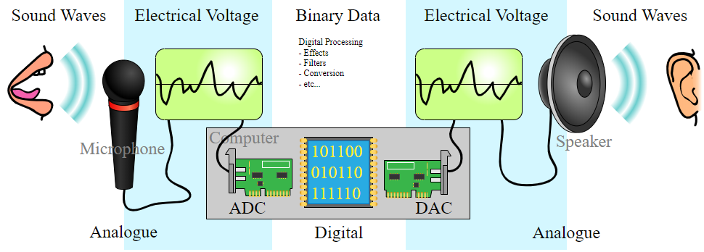

Figure 6:Analog to digital signals ‎[40]
- Analog to Digital Converter (ADC) - Converts analog sound into digital signals that can be stored on a computer.
Digital to Analog Converter (DAC) - Converts digital signals stored on a computer into analogue sound that can be played through devices such as speakers.
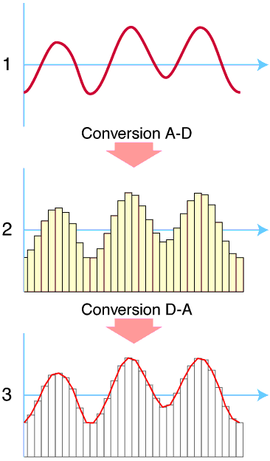
Figure 7: ‎‎[40]
(1) The original analog sound wave is a continuous set of points.
(2) ADC converts sound into digital data.
(3) DAC converts digital data into analog sound, the analog wave produced may differ significantly from the original sound wave.

Sound Compress
Pulse-code modulation (PCM) ‎[34] is a method used to digitally represent sampled analog signals. It is the standard form of digital audio in computers, compact discs, digital telephony and other digital audio applications. In a PCM stream, the amplitude of the analog signal is sampled regularly at uniform intervals, and each sample is quantized to the nearest value within a range of digital steps.
PCM audio can be encoded in many formats for the end user, and these formats fall into two categories: lossless and lossy.

Lossy
Lossy compression enables even greater reductions in file size by removing some of the audio information and simplifying the data. This, of course, results in a reduction in audio quality, but a variety of techniques are used, mainly by exploiting psychoacoustics, to remove the parts of the sound that have the least effect on perceived quality, and to minimize the amount of audible noise added during the process. The popular MP3 format is probably the best-known example, but the AAC format found on the iTunes Music Store is also common. Most formats offer a range of degrees of compression, generally measured in bit rate. The lower the rate, the smaller is the file and the more significant the quality loss.
- Lossy Formats
  - Mpeg Audio Layer 3 – mp3
  - Advanced Audio Coding – AAC

Lossless
A lossless compressed format stores data in less space without losing any information. The original, uncompressed data can be recreated from the compressed version. Uncompressed audio formats encode both sound and silence with the same number of bits per unit of time. Encoding an uncompressed minute of absolute silence produces a file of the same size as encoding an uncompressed minute of music. In a lossless compressed format, however, the music would occupy a smaller file than an uncompressed format and the silence would take up almost no space at all.
Lossless compression formats include the common FLAC, WavPack, Monkey's Audio, ALAC (Apple Lossless). They provide a compression ratio of about 2:1 (i.e. their files take up half the space of PCM). Development in lossless compression formats aims to reduce processing time while maintaining a good compression ratio. Lossless formats are: Waveform Audio File Format – WAV; Audio Interchange File Format – AIFF; Free Lossless Audio Codec – FLAC.

The difference between lossy and lossless compression
During processing, lossless compression rips audio files so that they reduce in size, but no quality is lost. It's a perfect copy of the original sound. You can also convert one lossless format to another without any loss of quality. But the one thing you can't ever do is converting lossless to lossy, not because it's impossible, it's just a stupid thing to do. For more info, read why converting FLAC to MP3 or WAV vs. MP3 is a terrible thing to do. On the other hand, lossy compression reduces the size of an original file up to ten times, so 100 MB become 10 MB, but some audio data is irreversibly lost therefore it may sound as if a song lacks something, or the other way round, some sound artifacts can appear.
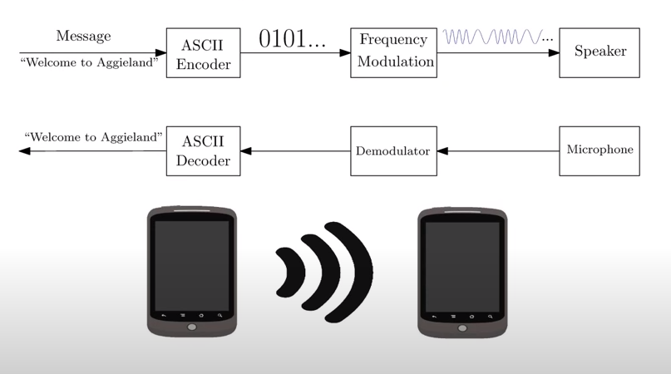
Figure 8: Overview of the transfer process without compressing/decompressing ‎[41]

Sound Decompress
Decompression is the process of restoring compressed data to its original form ‎[35]. Data decompression is required in almost all cases of compressed data, including lossy and lossless compression. Similar to compression of data, decompression of data is also based on different algorithms. Decompression is considered important, as compressed data needs to be restored back to standard state for usage. Decompression is widely used in data communications, multimedia, audio, video and file transmissions Decompression is also known as uncompression.
In Fig. 11 below, we can see the overview of the whole transfer process without compressing/decompressing. Compressing the message could be done before the ASCII encoder, and the decompressing should be done after the ASCII decoder.
The previous teams transfered a long string of data. To do so, they used compression and decompression. In our implementation ,we will rather focus on short strings of data. In light of that, we will not be using compression and decompression of data at first, but this might be used in future implementations.

Implementation details
To understand the design flow the reader is presumed to have an understanding of the following:
Pulse Code Modulation – PCM:
Pulse code modulation ‎[37] is a method that is used to convert an analog signal into a digital signal, so that modified analog signal can be transmitted through the digital communication network. PCM is in binary form, so there will be only two possible states high and low (0 and 1). We can also get back our analog signal by demodulation. The Pulse Code Modulation process is done in three steps Sampling, Quantization, and Coding. There are two specific types of pulse code modulations such as Differential Pulse Code Modulation (DPCM) and Adaptive Differential Pulse Code Modulation (ADPCM). Here (see Fig. 13) is a block diagram of the steps, which are included in PCM.
In sampling we are using PAM sampler that is Pulse Amplitude Modulation Sampler which converts continuous amplitude signal into Discrete-time- continuous signal (PAM pulses). Basic block diagram of PCM is given below for better understanding.
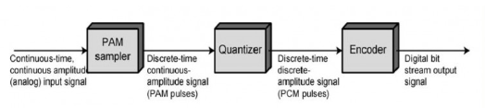
Figure 9: Block diagram of PCM ‎[37]
Pulse Code Modulation is:
To get a pulse code modulated waveform from an analog waveform at the transmitter end (source) of a communications circuit, the amplitude of the analog signal samples at regular time intervals. The sampling rate or number of samples per second is several times the maximum frequency. The message signal converted into binary form will be usually in the number of levels which is always to a power of 2. This process is called quantization.
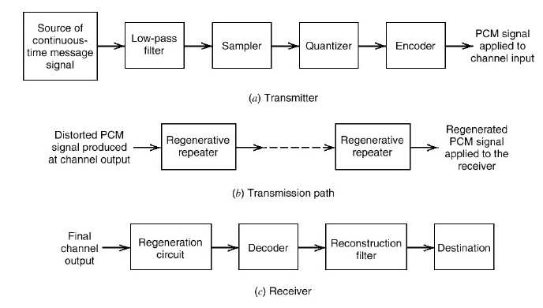
Figure 10: Basic elements of PCM system ‎[37]
At the receiver end, a pulse code demodulator decodes the binary signal back into pulses with same quantum levels as those in the modulator. By further processes we can restore the original analog waveform.
Pulse Code Modulation Theory
This above block diagram describes the whole process of PCM. The source of continuous time message signal is passed through a low pass filter and then sampling, Quantization, Encoding will be done. We will see in detail step by step.
Sampling
Sampling is a process of measuring the amplitude of a continuous-time signal at discrete instants, converts the continuous signal into a discrete signal. For example, conversion of a sound wave to a sequence of samples. The Sample is a value or set of values at a point in time or it can be spaced. Sampler extract samples of a continuous signal, it is a subsystem ideal sampler produces samples which are equivalent to the instantaneous value of the continuous signal at the specified various points. 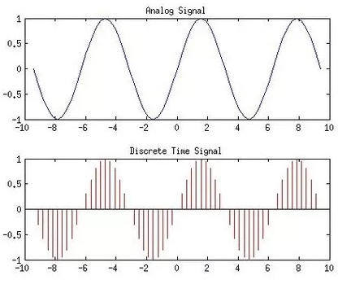
The Sampling process generates flat- top Pulse Amplitude Modulated (PAM) signal.
Figure 11: Analog and sampled signal ‎[37]
Sampling frequency, Fs is the number of average samples per second also known as sampling rate. According to the Nyquist Theorem sampling rate should be at least 2 times the upper cutoff frequency. Sampling frequency, Fs>=2*fmax to avoid Aliasing Effect. If the sampling frequency is very higher than the Nyquist rate it become Oversampling, theoretically a bandwidth limited signal can be reconstructed if sampled at above the Nyquist rate. If the sampling frequency is less than the Nyquist rate it will become undersampling.
- Nyquist Theorem: Nyquist rate is the rate at which sampling of a signal is done so that overlapping of frequency does not take place. When the sampling rate becomes exactly equal to 2fm samples per second, the specific rate is known as Nyquist rate. It is also known as the minimum sampling rate and given by fs =2fm.
- Ideal/Impulse Sampling: An impulse at each sampling instant with amplitude equals to signal at that point of time. 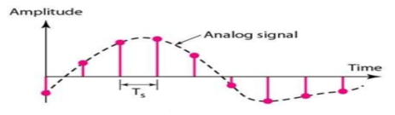
Figure 12: Ideal sampling ‎[43]
- Natural Sampling:
A pulse of short width with varying amplitude.
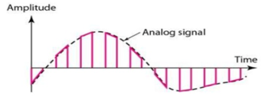
Figure 13: Natural sampling ‎[43]
- Flat-top Sampling:
Make use of sample and hold circuit almost like natural but with single amplitude value.
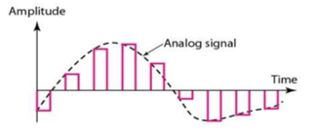Figure 14: Flat-top sampling ‎[43]
Quantization
In quantization, an analog sample with amplitude that converted into a digital sample with amplitude that takes one of a specific defined set of quantization values. Quantization is done by dividing the range of possible values of the analog samples into some different levels and assigning the center value of each level to any sample in quantization interval. Quantization approximates the analog sample values with the nearest quantization values. So, almost all the quantized samples will differ from the original samples by a small amount. That amount is called as quantization error. The result of this quantization error is we will hear hissing noise when play a random signal. Converting analog samples into binary numbers that represent the level number, e.g. suppose using 8-bit it means 2 to the power of 8 levels with values from 00000000 to 11111111 in binary.
We used uniform quantizers. Uniform quantization is applicable when the sample values are in a finite range (Fmin, Fmax). The total data range is divided into 2n levels, let it be L intervals. They will have an equal length Q. Q is known as Quantization interval or quantization step size. In uniform quantization there will be no quantization error.
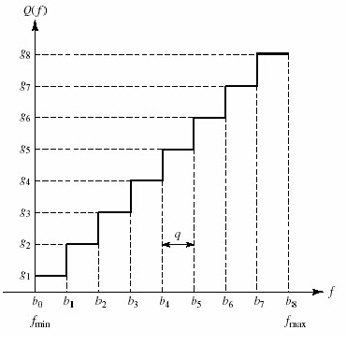
Figure 15: Uniformly quantized signal ‎[43]
Coding
The encoder encodes the quantized samples. Each quantized sample is encoded into an 8-bit code word by using A-law in the encoding process.
- Bit 1 is the most significant bit (MSB), it represents the polarity of the sample. “1” represents positive polarity and “0” represents negative polarity.
- Bit 2,3 and 4 will defines the location of sample value. These three bits together form linear curve for low level negative or positive samples.
- Bit 5,6,7 and 8 are the least significant bits (LSB) it represents one of the segments quantized value. Each segment is divided into 16 quantum levels.
PCM is two types Differential Pulse Code Modulation (DPCM) and Adaptive Differential Pulse Code Modulation (ADPCM).
In DPCM only the difference between a sample and the previous value is encoded. The difference will be much smaller than the total sample value, so we need some bits for getting same accuracy as in ordinary PCM. So that the required bit rate will also reduce. For example, in 5-bit code 1 bit is for polarity and the remaining 4 bits for 16 quantum levels.
ADPCM is achieved by adapting the quantizing levels to analog signal characteristics. We can estimate the values with preceding sample values. Error estimation is done as same as in DPCM. In 32Kbps ADPCM method difference between predicted value and sample value is coded with 4 bits, so that we’ll get 15 quantum levels. In this method data rate is half of the conventional PCM.

Expected Achievements: Our Approach- Ultrasonic sound based data transfer.
Our main goal is to have a communication network, based on ultrasonic waves at the end of the project. The implementation of the network will be based on collision avoidace protocol, and the maximum number of users per 2 meters radius (optimal reception area) will be 15 devices.
Our goal is to manage the transfer of data from many emitters to multiple recipians.
We want to be relevant to todays pandemic reality, and to make a product that can help in the matter. Our goal is to create a software that can monitor each persons encounters with other people in 2 meters radius or less, according to the recommendations of the national health security department during, approximately, 15 minutes.
We expect to successfully create a communication network between devices, based on ultrasonic waves. Our expectation is based on the fact that there are multiple non- wired communication networks, in addition to previous projects accomplishments.
The previous projects achieved data transfer communication between two devices, while we will expand this network, and enable the communication between multiple devices.
Based on our research, we expect to successfully create a communication network that works as follows:
The “Big Brother” application is designed to run in the background from the registration moment, and until the user removes the application from her/his device.
Each device will transmit and receive the information using the following communication protocol, which is based on collision avoidance protocol and waiting periods.
Since our communication network is based on ultrasonic sound waves, there is a very limited frequency range, which we can use for our application. As the previous teams, who worked on the project discovered, the best frequencies to use, assuming we use the Android based cellular devices, and the nature of our transmitted data, are between 18 KHz to 19 KHz.
Since the devices have limited sensitivity on these frequencies, we decided it would be best to continue to work on these frequencies as one communication channel, and not separate it to smaller frequency ranges or add higher ones. This means, in practice, all our communication network will be between 18 KHz to 19 KHz, when transmitting a bit on 18KHz will signify a ‘0’ and on 19Khz will signify a ‘1’.
After the user registered, the application will create a frame which will be sent to the devices around it, in predetermined intevals to each user (a prime number of some tokens), according to the network communication protocol established and the network load. We explain later how to define the interval.
Each frame will have 56 bits in the following structure:
- Starting character ‘F’: at the beginning of each frame will be the character ‘f’ that will mark the start of a new frame [ 4 bits].
- Data: The user ID [40 bits].
- Separating character ‘F’: This character will separate the data from the checksum [4 bits].
- Checksum: At the end of each message will be two characters of checksum to the message. This will be used for confirming the frame was received fully and correctly from the sender. The checksum will be calculated by adding the characters from the data section one to the other. [8 bits].
In total, it will take around 56 *0.27 (time to transfer each bit) = 15.12 millisecond to transmit the data.

One of the main outcomes of our research, was the clarification that due to the nature of wireless communication networks, our protocol should be strongly based on the collision avoidance protocol.
This is due to the fact that it is extremely hard to identify collisions on this kind on networks.
Nevertheless, on our protocol we do try to detect and handle the collisions, if and when they occure.
In order to further avoid the collisions, we added to the collision avoidance protocol, CSMA\CA, strict waiting periods. This way, ideally, each user in the network (in the two meters radius) will have a different waiting period. So, if, for example two, devices start their timers on the same time, they will finish the waiting in different times. It means that they will be able to continue to the next step of the protocol easly, in this case, to transmit their data to the other devices on the network.
We decided to use only prime numbers as the strict waiting periods, in order to minimize the propability of collisions inside the network. Our intention is to try to avoid cases where devics will have reoccurring collisions with each other, as a result of different waiting periods with a common bases. In addition, this is the best way to have a series of non-consecutive numbers with different gaps between each other.
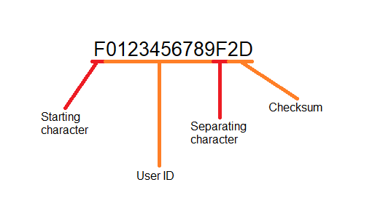
Figure 12:Frame structure
Our intention is that each user will have a different waiting period based on different prime numbers. Each user will wait a specific time period between each attempt to send her/his data. Ones a user successfully sends her/his data, s/he will begin another cycle of listening period. Each waiting period will be calculated using prime number and a constant number of seconds (a token). The token will represent a fraction of a minute equals 85 millisecond (=1/700 of a minute). This number was calculated by dividing the average of the prime numbers we will use, by 5 minutes. By doing so, we ensure different waiting periods to minimize collision and cycles of approximately 5 minutes. We may vary it to reach better collision avoidance.
On registration, the application will assign the user two numbers:
The first one, the regular base waiting period (RBWP), will be the higher number from the pair, and will be a prime number in the range of 2503-4493 (243 prime numbers).
The RWP number will be used as the base for calculating the cycle period for the specific user.
The second number, the minimal base waiting period (MBWP), will also be a prime number in the range of 59-1499 (223 prime numbers), when RBWP > MBWP. This number will be used as a base for a secondery waiting period, in case there is an error detected or a collision. In addition, if the device sample the channel in order to send its frame for more than one time, and the channel is still “busy”( – there might be other devices transmitting on frequencies 18 to 19 KHz at the sampling time), the application will wait MBWP instead of RBWP, in order to sample the channel more frequently than the other devices around it, and to avoid starvation.
After sending the message, the sender will wait for 2,000 milliseconds to hear if it receives an error signal from the receivers. We chose this number as an astimation for the time it will take to receive the full frame and to process it from audio to a checked data.
The application will have two main modes:
- Listening mode:
In this mode the application will listen to the device’s surrounding and receive the data, sent from other devices. The application will identify the beginning and ending of each frame and will process each frame separately (as explained below).
The listening mode is triggered by several scenarios.
  - The first trigger will be the finish of the registration process. In this case, the application will start by sampling the channel, and if it is clear (meaning no other device is transmitting at the moment) the application will trigger the transmitting mode. Otherwise, it will start a timer for RBWP, and when finished will sample the channel again. If the channel is silent, the device will transmit its frame. If not, it will continue in listening mode with a MBWP timer set.
  - The second trigger to the listening mode, is a succesful transmit of the user’s frame. In this case, the timer will be set to RBWP, and afterwards the application will sample the channel, and if it hears silence, it will transmit the frame again. If not, a timer will be set to the MBWP. When this timer will be finished, the application will sample the channel once more. If no one else is transmitting at the time, it will send its frame to the other device around it, and if there is someone who transmit at the moment, it will set another timer for MBWP.
  - The third and forth triggers of this mode, happens after transmitting the frame. The device listens to see if any other device returns an error signal as a response. If an error signal is received in the 2,000 milliseconds after sending the message, it means there was a collision, and the transmitting device will try to send its frame again by shifting to listening mode with timers set to MBWP. When the waiting period is over, the device sample the channel, and if it is silent transmit again.

- Transmitting mode:
In the transmitting mode, the application will send the pre- made frame with the user’s ID, to all the devices around it. This mode it triggered only after ensuring the channel is silent, meaning no other device is transmitting at 18-19 KHz frequency.
After the frame is transmitted, the application will switch to listening mode, and wait for error signals. If an error signal will be received, the application will wait for MBWP, and according to the state of the channel will return to the tramsmitting mode and send the frame again.

For example, below is a simulation of communication between 3 devices.
In this example [ fig. 13] , devices 1 and 2 enter the listening mode on “time 0”, while device 3 is listening in RBWP.
The waiting periods for each device are as follows:
Device 1:
MBWP: 59 * 1/700min = 8 milliseconds. RBWP: 2503 * 1/700min = 3.57 min.
Device 2:
MBWP: 71 * 1/700min = 10 milliseconds. RBWP: 3089 * 1/700min = 4.4 min.
Device 3:
MBWP: 79 * 1/700min = 11 milliseconds. RBWP: 4139 * 1/700min = 5.9min.
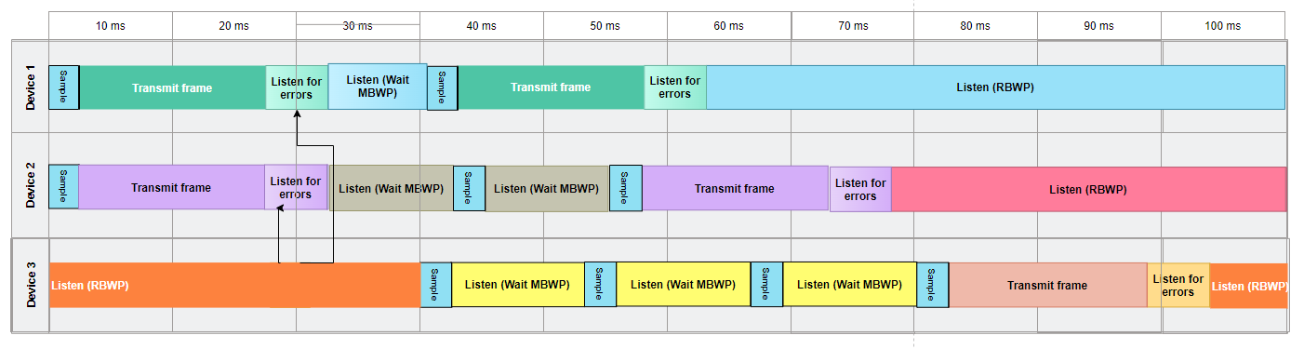
Figure 16: Simulation of communication between 3 devices

When in listening mode, the application will identify the beginning and ending of each frame, and will handle each frame it receives separately. The application will calculate the checksum of the frame, by adding the characters of the data section, and compare it with the one sent on the frame. If the checksum calculated is different from the one received on the frame, the device will send an error signal. If the two are identical, the device will save the information locally.
The local database contains one table, in which the data from the frame received is kept. The data saved is the user ID, the time of the first encounter, last encounter and a flag.
The local database on the device is designed in a manner that if this is the first time the application gets a specific user Id, it will add it to its storage. If the device recognized the user Id, and the last time seen is less then 10 minutes ago, it will be updated. If devices where near each other for 15 minute or more, the encounter will be flagged and saved.

Research / Engineering Process
Big Brother Software
Our goal is to create a software that can monitor each persons encounters with other people in 2 meters radius or less, during a period of 15 minutes, according to the recommendations of the national health security department. The previous teams successefully developed an application that passes a binary sequence. They iterated over the sequence and each time assigned 18 kHz to 0's and 19 kHz to 1’s. This method is called FSK.
Next, they played the resulted audio track with the highest amplitude to transmit the data to the second phone. They converted the recorded data from the domain of time to the domain of frequency using fast Fourier transform and chose from all the frequencies the marked frequency. Then, they
saved the digital data in the receiving device's local storage in a memory buffer.
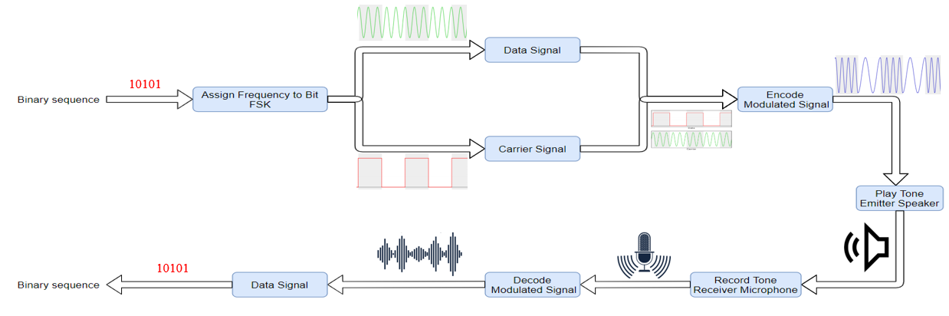
In our implementation we will transfer a unique identification sequence from each user to the others in his radius. We will do so by transmitting the identification sequence every RBWP (Regular Base Waiting Period). We chose that timespan after calculating the amount of time it will take for each device to transmite its identification sequence, and the number of devices we presume will be in a 2 meter radius at the same time (up to 15 devices).
Our implementation will be established on the communication protocol, based on collision avoidance protocol and a unique prime IFG waiting period.
This information will be stored locally on each device. In case one of the users will be tested positive to the corona viruse, all his encounters ,that lasted loner than 15 minutes, will be uploaded to the cloud. This information will be confidentioal and will be shared with the health authorities alone.
The user can upload his encounters to the cloud at any point. When uploading the data to the cloud, the information will be removed from local storage.
Figure 17: Transmit To Receive Flow
The application will always run in the backround. Sending and receiving data through ultra sound waves, will be based on the achievements of the previous teams [as specified previously].
The devices will work according to the protocol below for transmitting data:
1. When a frame (the data to transmit, checksum and two flags representing the start of the data and separation of the data and the checksum) is ready, the device checks whether the frequency is idle (silent) or busy (not silent).
2. If the frequency is busy, the device will start listening for MBWP (minimal base waiting period).
3. If the frequency is idle, the device sends the frame.
4. After sending the frame, it waits for 2,000 milliseconds to hear if any device return a collision signal. (as explained in chapter 3).
4.1 If there was a collision- the device will wait for IFG time (MBWP) and will send the frame again.
8. Otherwise, it starts listening and waits for RBWP and restarts the algorithm.

Materials
The provided investigation of ‎[18] uses FSK functions of ‎[8] by encoding binary 1’s and 0’s as two different frequencies. Each frequency must be predetermined. Their experiments use 18 kHz as the low frequency and 19 kHz as the high frequency. These 1’s and 0’s may be referred to as bits or symbols. If the receiver senses a high tone, it receives a 1. If it receives a low tone, it receives a 0. FSK also uses a set amount of time for each symbol to maintain synchronization and detect repeats of the same symbol. An illustration describing FSK is presented in Fig. 4. The frequencies 18 kHz and 19 kHz were chosen for various reasons. Lower frequencies should be able to travel farther while maintaining their integrity. These frequencies were still too high for the author and experimenters to hear. Hanspatch and Goetz, cf. ‎[9] , used a frequency of 18,600 Hz. The provided investigation ‎[18] found that error rates were significantly higher when they used 19 kHz and 20 kHz. This is likely due to hardware limitations.

Communication protocol
The communication will work as follows:The application will work relentlessly on the users device from the moment of registration until the application is deleted. All the devices will listen and transmit the data on the same frequencies.
We will use the frequencies 18 – 19 KHz, as described in Secoion 4.1 above. Each device will try transmitting its data (in our case, the identification sequence) every RBWP (Regular Based Waiting Period) time. The device will listen to the frequencies. If there is silence, and it is its time to transmit the data, transmission will start. Otherwise it will receive the data that is being transferred.
When the devices' tansmission time arrives, and if the frequencies are silent, the device will start transmiting the frame. Otherwise the device will wait for minimal based waiting period (MBWP), and check if the frequency is free for transmission. The device will stay in this loop until it is able to transmit the data. By using firstly RBWP and then, in case of failure, MBWP we decrease the chance of starvation for each device. In addition to the time of each cycle (explained in Section 4.4) that will have a large gap of time for all the devices to do the transmission.
When the device is listening to the frequencies, it recives data from other users. When reciving the data, the device will check if a collision or an error occurred by checking the checksum in the message and commpering it to the sum of digits of the data. If an error or a collision happened, the reciving device will start transmiting an error signal immediately to the sender. By doing so, the device that transmitted the data will know an error happened and will start the cycle of re-transmission, this time using MBWP only, to decrease the change of starvation.
Each time, the sender will wait for a prime IFG time (RBWP or MBWP), in order to minimize the probability for collisions in the network. After the sender sent its data and finished the process, it will initiallize the timer for the next round of the process of sending its data. This time will be determined by the Corona- virus regulations – at the moment, it will be set to RBWP time. If the devices encountered each other for at least for 15 minutes in a row, the data will be flagged. If a device “meets” another device, for less than 15 minutes in a row, its data will be removed from the local database.
As long as the device is not transmitting data, it is in the listening mode. While in the listening mode, the device may semple the channel. This action will not interfere in the listening process. Meaning if the device receives a frame at that time, the sempaling and the frame reciving will happen simultaneously.
The "Big Brother" will transmite the users ID as a frame.

Cycles of transmission:
The "Big Brother" application will work relentlessly on the users device. Due to this fact, the device will not have a clear and enforced time to transmit the information. We decided that the application will work in cycles, and every RBWP (Regular Based Waiting Period) time the device will try to transmite the data. The reasons for this specific time frame are:
The National health department protocol for social distancing states that to be infected, an individual needs to be in proximity of 2 meters or less, to an infected person during 15 minutes or more.
Furthermore the transmition time of 56 bits (which represent the identification sequence) is calculated as demonstrated:
We found that the best duration time to play a tone representing a bit is 0.27 milliseconds.
The message that will be sent, will be constructed of:
10 digits of the identification sequence (the users cellphone number), thus 4*10 = 40 binery digits = 40 bits.
4 bit sequence to flag the start of the data and the separation of the data and the checksum, in conclusion 8 bits.
8 bit sequence representing the checksum. We will be using checksum to detect collitions and errors in transfer. The checksum will be build out of the sum of all the digits of the data.
In total, we will transmit 40+4+4+8= 56 bits.
By this calculation it will take 56*0.27 = 15.12 milliseconds to transfer the entire message.
Consequently, we decided on RBWP cycles as the optimal option to not "miss" any encounter between two people. We chose the RBWP range to be such that when calculating the waiting periods, it will be around 5 minutes. This way, if two users were detected by the application, for 15 minutes in a row, they are flaggd in the local data base, as there is a risk of one infecting the other.
The application will save in a local data base all the encounters.

Application Data Base:
The application will have two Data Bases (DBs), one local and one on the cloud. Both data bases will have the following fields: id, starting time of meeting (date and time), last encounter recorded time.
In addition to those fields, the local data base will have remember flag.
Every time the device gets a new message, the data (in our case, the other users id) will be compared to the local data base. If the received id exists in the DB) and the last encounter recorded was less then 15 minutes ago (due to the corona-virus regulations) , this field will be updated.
If the last encounter was 15 minutes or more from the first encounter, this means the two users were a long enough time in proximity to be at risk of infection if one of them is ill. In this case the remember flag at the local DB will be raised. This will mean that this data can not be erased from the local DB until an update to the cloud was made.
In case two users were in proximerty less then 15 minutes and the last encounter was more then 15 minutes ago, this information can be erased from the local DB. The reason for this is the minimal chance those two users have of infecting each other in view of the health department recommendations.
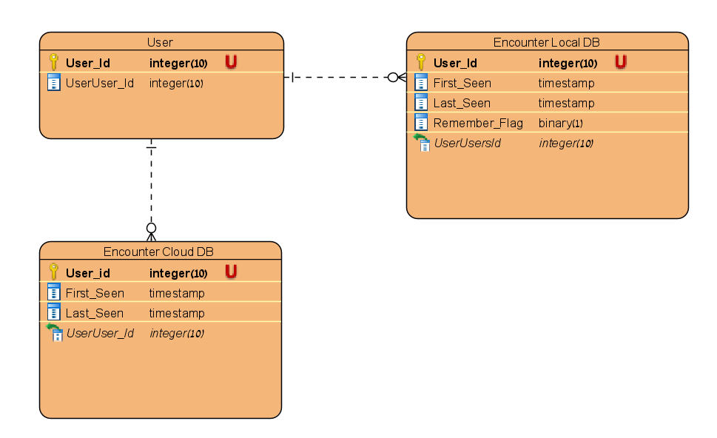
Figure 18: The initial ERD diagram of our database

Emitter Side:

Generate Tone In A Specific Frequency And Duration – Android API
AudioTrack Class:
The AudioTrack ‎[38] class manages and plays a single audio resource for Java applications. It allows streaming of PCM audio buffers to the audio sink for playback. This is achieved by "pushing" the data to the AudioTrack object using one of the write(byte[], int, int), write(short[], int, int), and write(float[], int, int, int) methods.
An AudioTrack instance can operate under two modes: static or streaming.
In Streaming mode, the application writes a continuous stream of data to the AudioTrack, using one of the write() methods. These are blocking and return when the data has been transferred from the Java layer to the native layer and queued for playback. The streaming mode is most useful when playing blocks of audio data that for instance are:
- too big to fit in memory because of the duration of the sound to play,
- too big to fit in memory because of the characteristics of the audio data (high sampling rate, bits per sample ...)
- received or generated while previously queued audio is playing.
The static mode should be chosen when dealing with short sounds that fit in memory and that need to be played with the smallest latency possible. The static mode will therefore be preferred for UI and game sounds that are played often, and with the smallest overhead possible.
Upon creation, an AudioTrack object initializes its associated audio buffer. The size of this buffer, specified during the construction, determines how long an AudioTrack can play before running out of data. For an AudioTrack using the static mode, this size is the maximum size of the sound that can be played from it. For the streaming mode, data will be written to the audio sink in chunks of sizes less than or equal to the total buffer size.

Pseudo Code
- Initialize:
  - SampleRate = 44100KHz // num of sampling in each second
  - Duration // num of seconds to playing the tone
  - NumOfSamples = SampleRate*Duration
  - SoundData[NumOfSamples]
  - Sampls[NumOfSamples]
  - Ramp = NumOfSamples
- For i = 0 to DataChuncks.size()
  - For j = 0 to NumOfSamples
    - If DataChuncks[i] = 0 Frequency = 18KHz
    - If DataChuncks[i] = 1 Frequency = 19KHz
    - Samples[j] = sin(2*PI*Frequency*i/SampleRate)
  - Ramp = NumOfSamples /20
  - For i = 0 to ramp
  - ramp amplitude up to avoid clicks
  - For i = i to NumOfSamples
  - max amplitude for most of the samples
  - for i = i to NumOfSamples
  - ramp amplitude down
  - instantiate AudioTrack class
  - call write function
  - if Frequency is silent
    - call play function
    - initialize cycle_timer.
  - Else turn to Receiver side
Receiver Side:

Record A Specific Tone – Android API
AudioRecord Class:
The AudioRecord class manages the audio resources for Java applications to record audio from the audio input hardware of the platform. This is achieved by "pulling" (reading) the data from the AudioRecord object. The application is responsible for polling the AudioRecord object in time using one of the following three methods: read(byte[], int, int), read(short[], int, int) or read(java.nio.ByteBuffer, int). The choice of which method to use will be based on the audio data storage format that is the most convenient for the user of AudioRecord.
Upon creation, an AudioRecord object initializes its associated audio buffer that it will fill with the new audio data. The size of this buffer, specified during the construction, determines how long an AudioRecord can record before "over-running" data that has not been read yet. Data should be read from the audio hardware in chunks of sizes inferior to the total recording buffer size.

Pseudo Code
- Initialize:
  - Instantiate AudioRecord Class as Recorder
  - MinBuffSize = AudioRecord.getMinBufferSize
  - DataBuff[MinBuffSize]
  - IsRecording = 1
  - StartOffset = 0
  - DataFile of type ByteArrayOutputStream
- Recorder.startRecording()
- While IsRecording > 0 //Recording according to Frequency (from emmiting)
  - IsRecording= Recorder.read(DataBuffer, StartOffset, MinBuffSize)
  - Write DataBuff to DataFile
- If cycle_timer == RBWP*(1/700)minutes
  - Turn to emitter side.
- Else return to step 1.

Read audio buffer
When the device switches to emitter mode, the recording is converted to binery digits from audio

Pseudo Code
- Recorder.stop()
- ChunckSize = DataFile.size() / (SampleRate * Duration)
- Index = 0
- FrequencyArray[SampleRate*Duration]
- Frequency = 0
- DataBit = 0
- StrBinaryChuncks
- foreach sub buffer in DataFile
  - For j = 0 to SampleRate*Duration
    - FrequencyArray[j] = FourierTransform(DataFile[s++])
  - for k = 0 to FrequencyArray.size()
    - If 18.5KHz <= FrequencyArray[k] <= 19KHZ and has higher amplitude than all the previous
      - then DataBit = 1
    - If 18KHz <=FrequencyArray[k] < 18.5 KHz and has higher amplitude than all the previous
      - then Databit = 0
  - StrBinaryChuncks += DataBit

Convert received message to data
Now we have the received message but it is in binary. We will split the message into 4-bit blocks. We will do so, because we want to convert all the binary sequences to decimal digits.
Firstly we will check that the first 4 digits are all 1's (representing the start flag). Then we will convert all the 4-bit blocks to decimal digits and check that the number of blockes/decimal digits is equal to 10 (to make sure we got the full users id). Next we will check again for 4 1's in a row representing the flag separating the data from the checksum, and convert the next two blocks of 4 bits to decimal digits representing the checksum. In case one of the flags is missing or the number of bits we received is incorrect, we will send an error signal from the receiver side.

Check for errors in the resived message
Before we save the data, we need to make sure no collision occurred during transfer. To do so we will check the sum of the digits we received as data and the checksum number. We will sum all the data digits (the data is 10 decimal digits) and comper it to the checksum. If they are equal, the transformation was successful and we will save the data in the DB. Otherwise we will send an error signal.

Save the date representing an encounter
The data we received, represents an encounter between two people in 2 meter proximity. We would want to save this information in the local DB so we will eventually have a log of all the users encounters and their duration. To achieve that we will go through the local DB and check if this id (the data we recived is the id of the other user) already exists. If the id is a not known to the DB, we will save it and initialize all the additional fileds (first time seen, last time seen (will be equal to the first time seen at first), number of encounters (will be initialized to 1) and remember falg (will be 0 at first)).
If the id exists in the DB, we will check the last time seen. If more then 15 minutes passed, we will save this encounter as a new one. Otherwise we will update the last time seen, increase the number of encounters and if the number of encounters is 3 or greater, we will turn the remember flag on.

Upload local DB to the cloud
When the user press the upload button in the application, all the encounters that are saved in the local DB with the remember flag on, will be uploaded to the cloud and removed from the local DB. Since we will use an Android integrated development environment, we will use one of the methods that are offered in the Java libraries.

Preliminary Software Engineering - Product

Class Diagrams
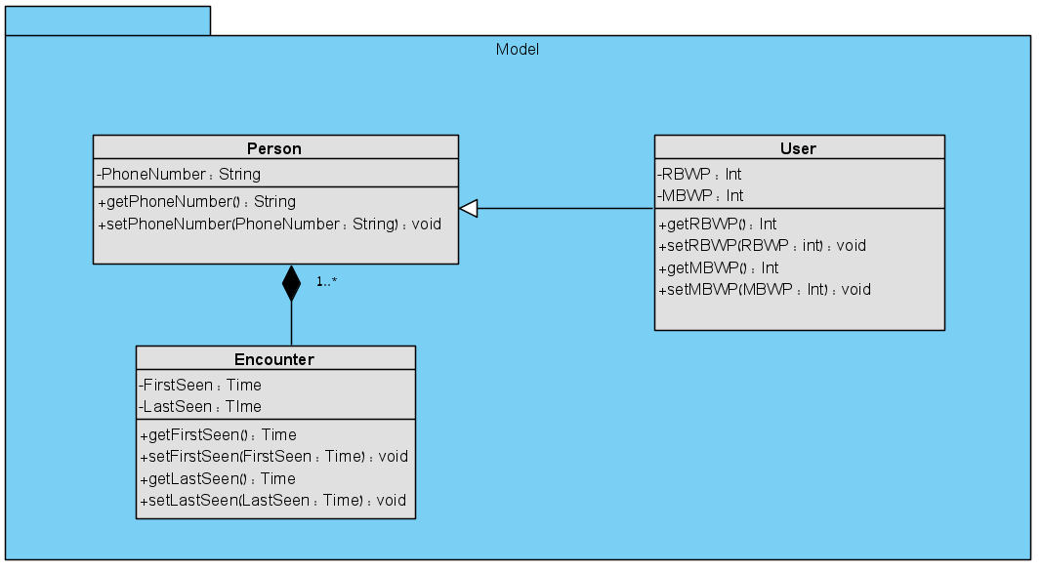
Figure 22: Class diagram- Model
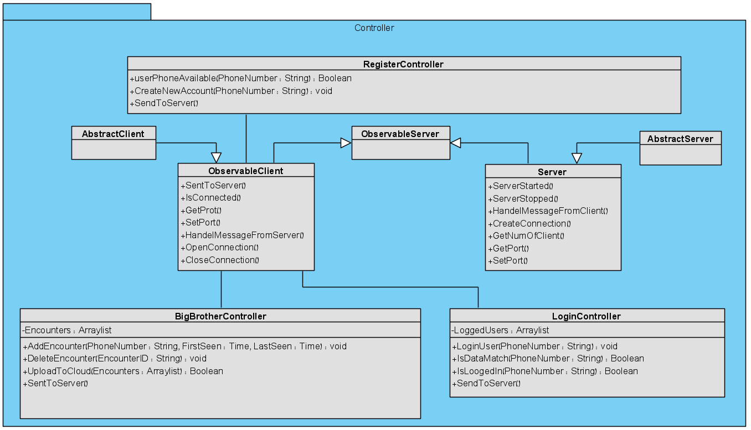
Figure 23: Class diagram- Controller

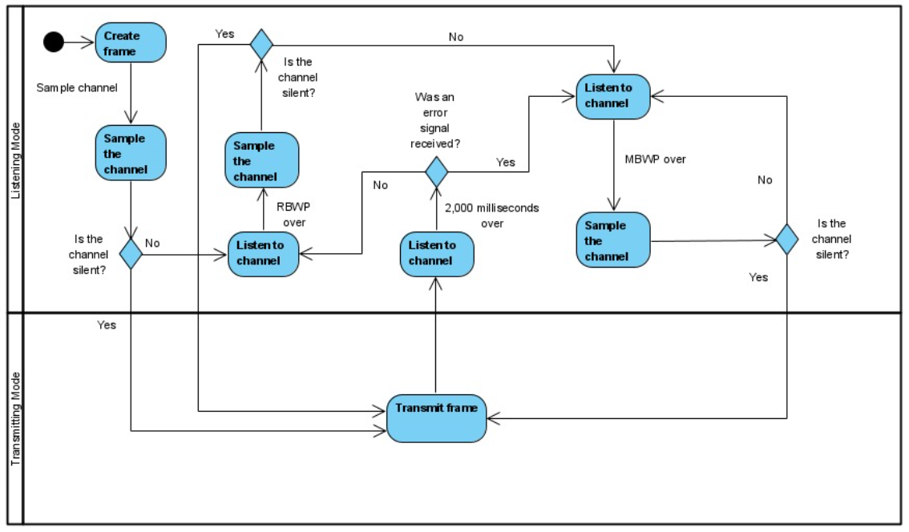
Activity Diagrams

Figure 24: Activity Diagram- Big Brother

Evaluation/Verification Plan-Testing plan
Our application is engineered in a way that there is no user interface, all actions happen in the backgraound without user interference. As a result all of our testing will be on the transmission process and network structure.
The testing process will be as follows:
Test ID | Number of Devices | Description | Expected Results
Simple interaction | 2 | Send a frame from one device to the other. | The second device resived the frame correctly.
Incorrect checksum | 2 | Send a frame with incorrect checksum from one device to the other. | The second device sends an error signal.
5 minutes interaction | 2 | Position the devices 2 meter apart and wait for 5 minutes. | The encounter was logged in the data bases of both devices. The flag was not raised.
15 minutes interaction | 2 | Position the devices 2 meter apart and wait for 15 minutes. | The encounter was logged in the data bases of both devices. The flag was raised.
Interaction with collision | 3 | Send frames from 2 devices at the same time to create a collision. | The third devices identifies a collision and sends an error signal.
Two devices with the same RBWP | 3 | Two devices start the waiting time cycle simultaneously and with the same wating time period. Wait 5 minutes. | The third device received the frames of the two other devices correctly after 5 minutes.
5 minutes interaction- multiple devices | 3 - 15 | Position the devices 2 meters apart and wait for 5 minutes. | All the devices will “Know” all the other devices.
Removing short encounters | 7 | Position the devices 2 meters apart. Wait for 10 minutes and remove 3 devices. Position the devices 100 meters apart for 15 minutes. | The long encounters were registered and flagged on the devices and the short ones were deleted.
Upload to the cloud | 1 | On a device with at least one flagged interaction and one not flagged interaction on the database. Upload to the cloud. | The flagged encounters (only) were uploaded to the cloud and removed from the local database.
Multiple encounters, same devices | 2 | Position 2 devices close for 5 minutes, then separate them for 10 minutes and put them together again for additional 5 minutes. | The device will have two separated encounters - not flagged.
Table 2: Test Plan

References
- A ring tone meant to fall on deaf ears - new york times. Web site: https://www.nytimes.com/2006/06/12/technology/12ring.html?r
- Android operating system what is that? https://www.elprocus.com/what-is-android-introduction-features-applications/
- BERESFORD, A. R., RICE, A., SKEHIN, N., AND SOHAN, R. Mockdroid: trading privacy for application functionality on smartphones. In Proceedings of the 12th workshop on mobile computing systems and applications (2011), ACM, pp. 49–54.
- ENCK, W., GILBERT, P., CHUN, B.-G., COX, L. P., JUNG, J., MCDANIEL, P., AND SHETH, A. Taintdroid: An informationflow tracking system for realtime privacy monitoring on smartphones. In OSDI (2010), vol. 10, pp. 1–6.
- ENCK, W., ONGTANG, M., AND MCDANIEL, P. Mitigating android software misuse before it happens. Citeseer (2008).
- Henning D, Sabic E and Hout M (2018) Hear and There: Sounds from Everywhere! Front. Young Minds. 6:63. doi: 10.3389/frym.2018.00063 - https://kids.frontiersin.org/article/10.3389/frym.2018.00063#KC2
- what is Ultrasonic? https://www.wikilectures.eu/w/Ultrasound, https://en.wikipedia.org/wiki/Ultrasound
- Frequency-shift keying - wikipedia, the free encyclopedia. Web site: http://en.wikipedia.org/wiki/Frequencyshiftkeying
- HANSPACH, M., AND GOETZ, M. On covert acoustical mesh networks in air. Journal of Communications 8, 11 (2013).
- Amplitude Modulation - https://en.wikipedia.org/wiki/Amplitude_modulation
- "Father Landell de Moura: Radio Broadcasting Pioneer : FABIO S. FLOSI : UNICAMP – University of Campinas, State of São Paulo" (PDF). Aminharadio.com. Retrieved 15 July 2018.
- Frequency Modulation - https://en.wikipedia.org/wiki/Frequency_modulation
- Stan Gibilisco (2002). Teach yourself electricity and electronics. McGraw-Hill Professional. p. 477. ISBN 978-0-07-137730-0. morse-code frequency-shift-keying sent-using-fsk.
- David B. Rutledge (1999). The Electronics of Radio. Cambridge University Press. p. 310. ISBN 978-0-521-64645-1.
- B. Boashash, editor, "Time-Frequency Signal Analysis and Processing – A Comprehensive Reference", Elsevier Science, Oxford, 2003; ISBN 0-08-044335-4
- Phase Modulation - https://en.wikipedia.org/wiki/Phase_modulation
- Data over Sound – Alternative Data Transfer Methods – https://www.thewindowsclub.com/data-sound-alternative-data-transfer-methods
- Inaudible Sound as a Covert Channel in Mobile Devices https://www.usenix.org/system/files/conference/woot14/woot14-deshotels.pdf
- Patents - https://sonicontrol.fhstp.ac.at/soniwiki/index.php/Patents_on_Ultrasonic_Communication
- Analog modulation - https://en.wikipedia.org/wiki/Modulation#Analog_modulation_methods
- Digital modulation - https://en.wikipedia.org/wiki/Modulation
- Amplitude shift keying - https://en.wikipedia.org/wiki/Amplitude-shift_keying
- Carrier wave - https://en.wikipedia.org/wiki/Carrier_wave
- Phase shift keying - https://en.wikipedia.org/wiki/Phase-shift_keying
- Three methods of digital signal modulation - https://www.britannica.com/technology/telecommunication/Modulation
- comparison chart - https://www.diffen.com/difference/Analog_vs_Digital
- very high frequency - https://en.wikipedia.org/wiki/Airband
- Quadrature amplitude modulation - https://en.wikipedia.org/wiki/Quadrature_amplitude_modulation
- How Smartphones transfer data via sound? https://www.electronicdesign.com/industrial-automation/article/21808186/sending-data-over-sound-how-and-why
- Quick Response Code - https://en.wikipedia.org/wiki/QR_code
- Voice over Internet Protocol - https://en.wikipedia.org/wiki/Voice_over_IP
- Audio file types - https://www.canto.com/blog/audio-file-types/
- AIFF - https://www.abyssmedia.com/formats/aiff-format.shtml
- PCM Sound - https://en.wikipedia.org/wiki/Pulse-code_modulation
- Sound Decompress - https://www.techopedia.com/definition/14330/decompression
- SDK - https://whatis.techtarget.com/definition/software-developers-kit-SDK
- PCM - https://www.elprocus.com/pulse-code-modulation-and-demodulation/
- AudioTrack - https://developer.android.com/reference/android/media/AudioTrack
- AudioRecord - https://developer.android.com/reference/android/media/AudioRecord
- Analog to digital - https://en.wikibooks.org/wiki/A-level_Computing/AQA/Problem_Solving,_Programming,_Data_Representation_and_Practical_Exercise/Fundamentals_of_Data_Representation/Analogue_and_digital
- Overview of the transfer process - https://www.youtube.com/watch?v=kb_e3DPPdsU
- Analog to digital conversion - https://www.britannica.com/technology/telecommunication
- Overview sampling - https://www.slideshare.net/SaggiLohana/overview-of-sampling
- Network collision- https://techterms.com/definition/collision
- Carrier – sense multiple access with collision detection - sense_multiple_access_with_collision_detection
- Carrier-sense multiple access with collision avoidance - https://en.wikipedia.org/wiki/Carrier-sense_multiple_access_with_collision_avoidance
- What is the reason CSMA/CD can't be used on wireless network - https://serverfault.com/questions/452675/what-is-the-reason-csma-cd-cant-be-used-on-a-wireless-network
- CSMA/CA algorithm- https://www.tutorialspoint.com/csma-with-collision-avoidance-csma-ca
- The CSMA/CD Algorithm - https://www.tutorialspoint.com/csma-with-collision-detection-csma-cd
- How Does WiFi Work? - https://sookocheff.com/post/networking/how-does-wifi-work/#:~:text=Therefore%2C%20instead%20of%20collision%20detection,channel%20is%20idle%2C%20like%20Ethernet.
- Wifi - https://en.wikipedia.org/wiki/Wi-Fi#:~:text=Wi%2DFi%20(%2F%CB%88w,exchange%20data%20by%20radio%20waves.Buetooth (2003): Bluetooth Network Encapsulation Protocol (BNEP) Specification
- Bluetooth- https://learn.sparkfun.com/tutorials/bluetooth-basics/all
- User Datagram Protocol- https://www.cloudflare.com/learning/ddos/glossary/user-datagram-protocol-udp/

